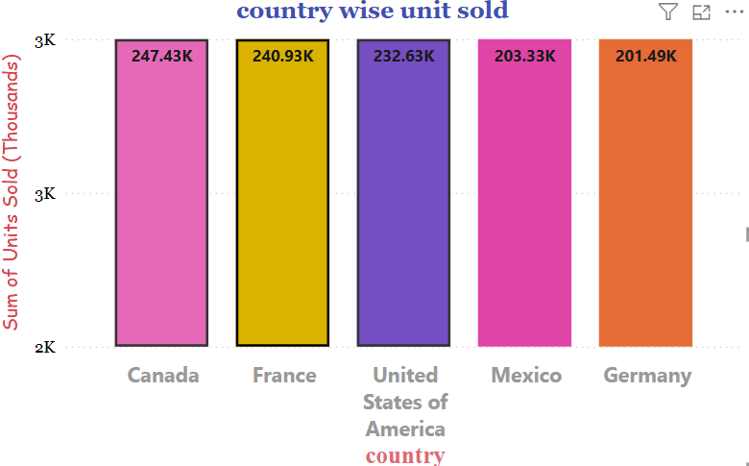

**COUNTRY WISE UNIT SOLD**

**Steps :**

**In report view tab :**

1**.**visualizations tab -> buid visual

2 . click on stacked column chart

**Data tab :**

1 . Financials -> select columns name according to the given question

**Build visual :**

1. X-axis ->country
2. Y-axis -> unit sold

**Format visual :**

1. Format visual -> visual

**x-> axis :**

value

font -> segoe ui bold

Size -> 13,bold

Color -> block 60% lighter

Title

Title text -> country

Style -> show tittle only

Font -> arial Unicode Ms

Size -> 15,bold

Color -> theme color 8,20% lighter

**Y – axis :**

R

Minimum – 2000

Maximum – 3000

Values

Font -> Georgia

Size -> 10

Color -> block

Display units -> thousands

Title

Title text -> auto

Style -> show tittle only

Font -> comic sans Ms

Size -> 12

Color -> theme color 8

Columns

Categories ;

Canada ->#e669b9

France -> color theme 7

United stats of America -> color theme 6

Mexico -> color theme 5

Germany -> color theme 8

Border

Color -> black

Data lables :

Data lables - apply settings to

Series -> all

Options

orientation -> horizontal

Position -> auto

Values

Filed -> sum of units sold

Font -> segoe un